Project Planning Phase

**Project Planning Template (Product Backlog, Sprint Planning, Stories, Story points)**

|  |  |
| --- | --- |
| Date | 18 NOVEMBER 2022 |
| Team ID | PNT2022TMID31303 |
| Project Name | AI-powered Nutrition Analyzer for Fitness  Enthusiasts |
| Maximum Marks | 8 Marks |

Project Tracker, Velocity & Burndown Chart: (4 Marks)

|  |  |  |  |  |  |  |
| --- | --- | --- | --- | --- | --- | --- |
| **Sprint** | **Total Story Points** | **Duration** | **Sprint Start Date** | **Sprint End Date (Planned)** | **Story Points Completed (as on**  **Planned End Date)** | **Sprint Release Date (Actual)** |
| Sprint-1 | 20 | 6 Days | 24 OCT 2022 | 29 Oct 2022 | 20 | 29 Oct 2022 |
| Sprint-2 | 20 | 6 Days | 31 Oct 2022 | 05 Nov 2022 | 20 | 05 Nov 2022 |
| Sprint-3 | 20 | 6 Days | 07 Nov 2022 | 12 Nov 2022 | 20 | 12 Nov 2022 |
| Sprint-4 | 20 | 6 Days | 14 Nov 2022 | 19 Nov 2022 | 20 | 19 Nov 2022 |

Velocity:

Average Velocity = 12/4 = 3

Burndown Chart:

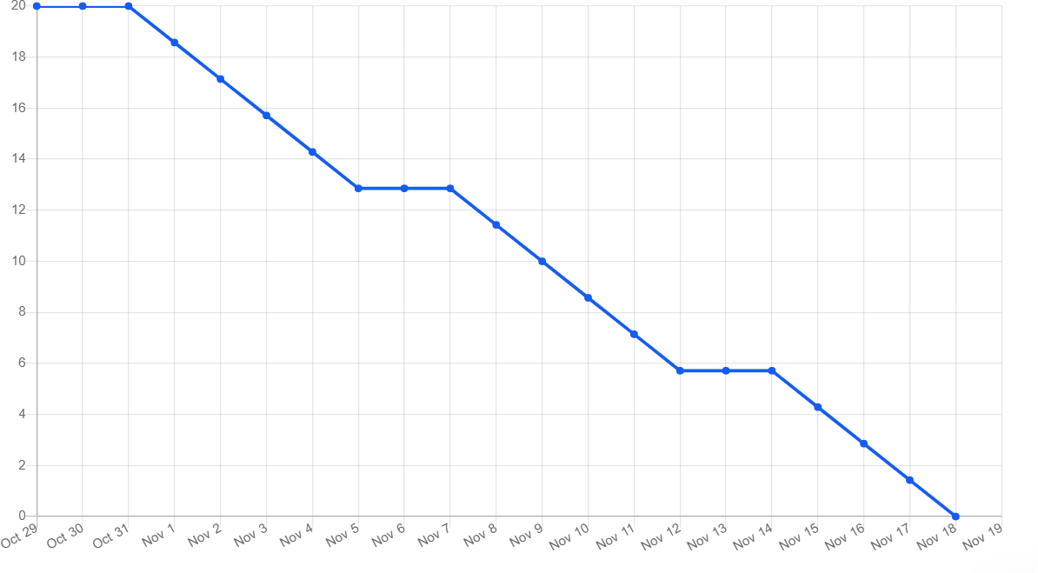

Roadmap:

